Lab task 8.1

Exercise 1

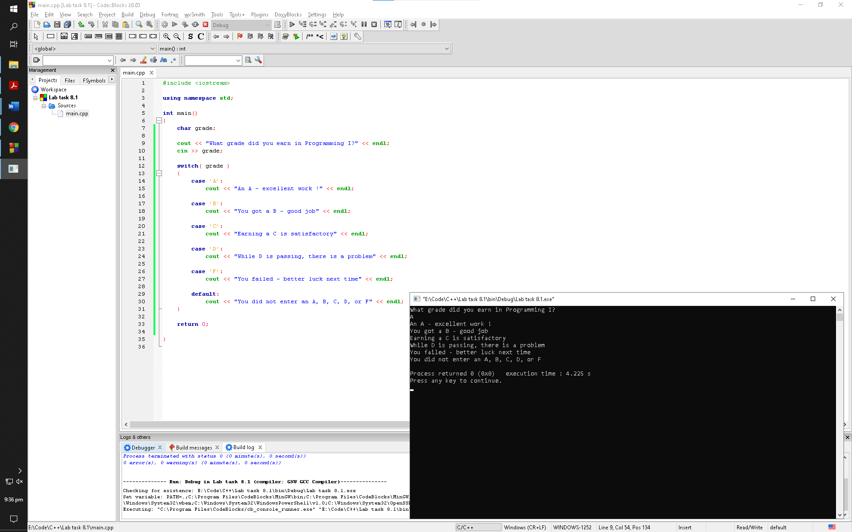

Observation: Without the break statements the program keeps on prompting the user with cout statements from the leading case condition

Exercise 2

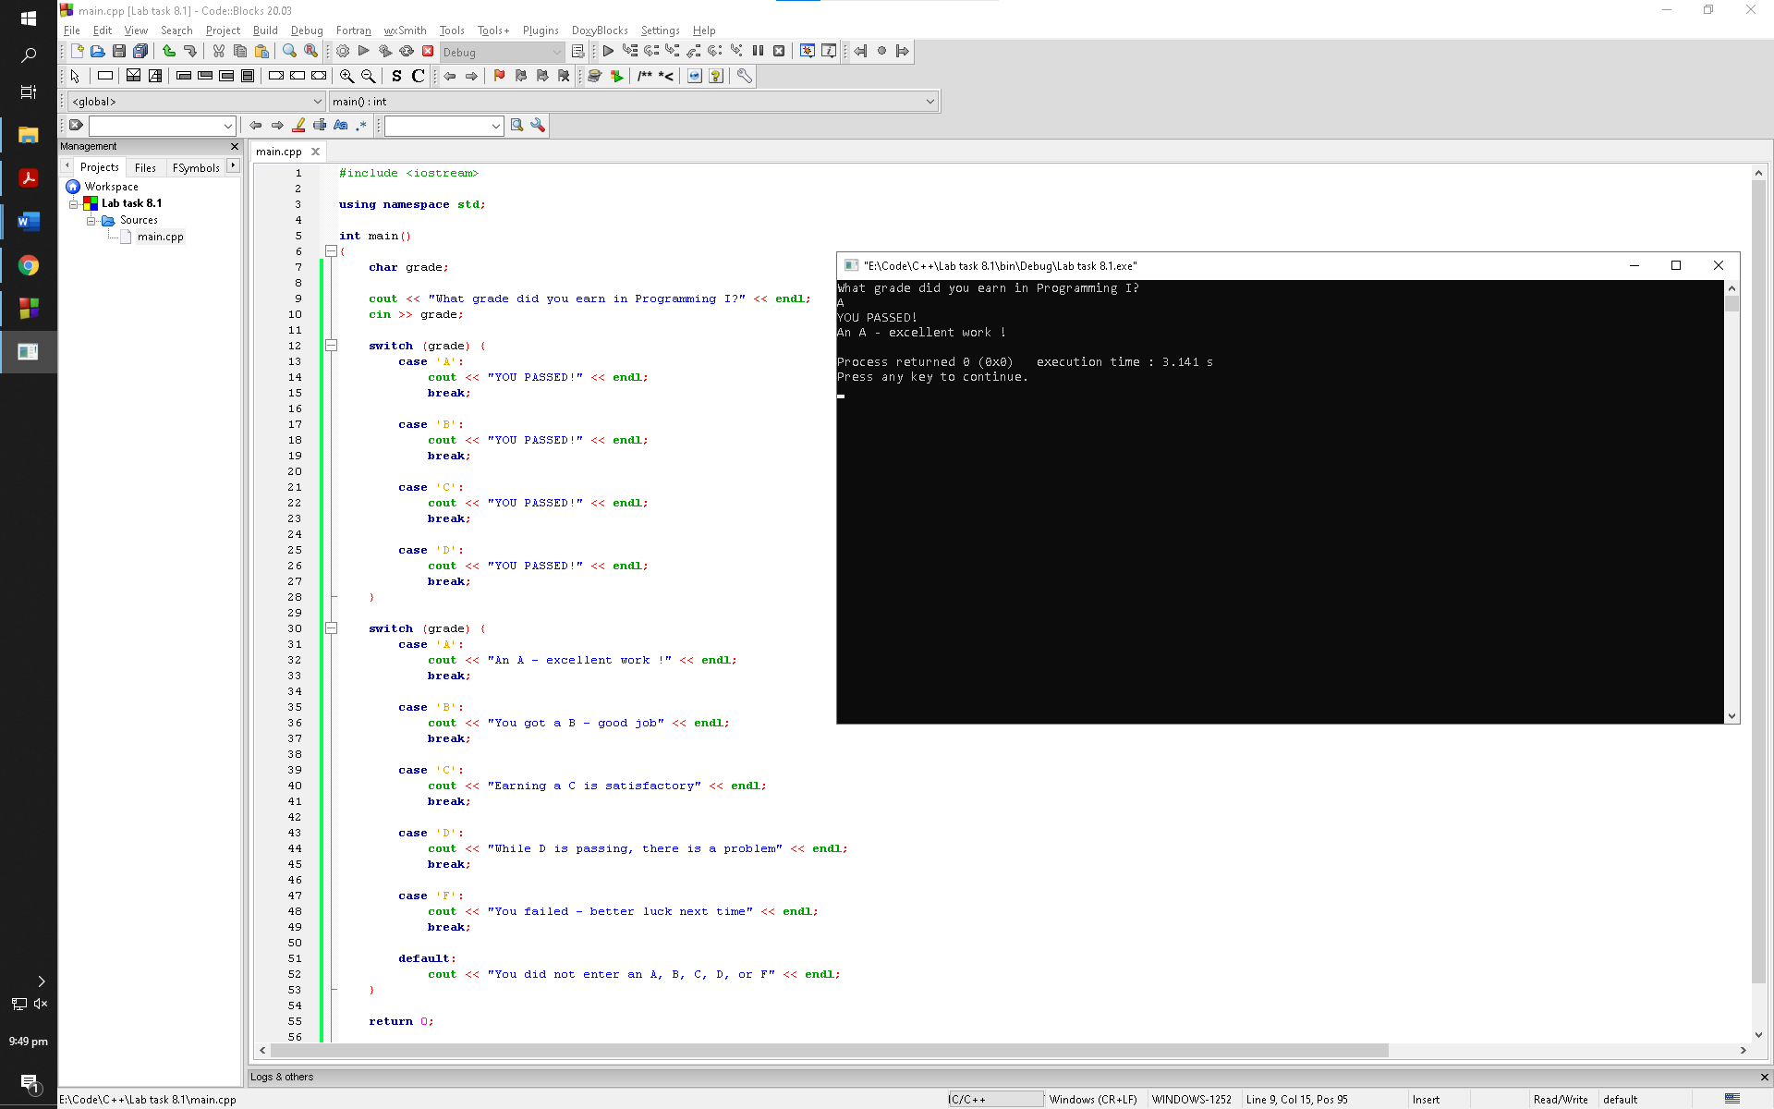

Observation: After taking in input from the user the program goes through the first switch statement and check for any cases if they are true. If they are, the program prints out the cout statement and then moves forward. It does the exact same thing with the second switch statement. If the user inputted something that the program is not familiarized with, it simply prints out the default statement present in the second switch statement

Exercise 3

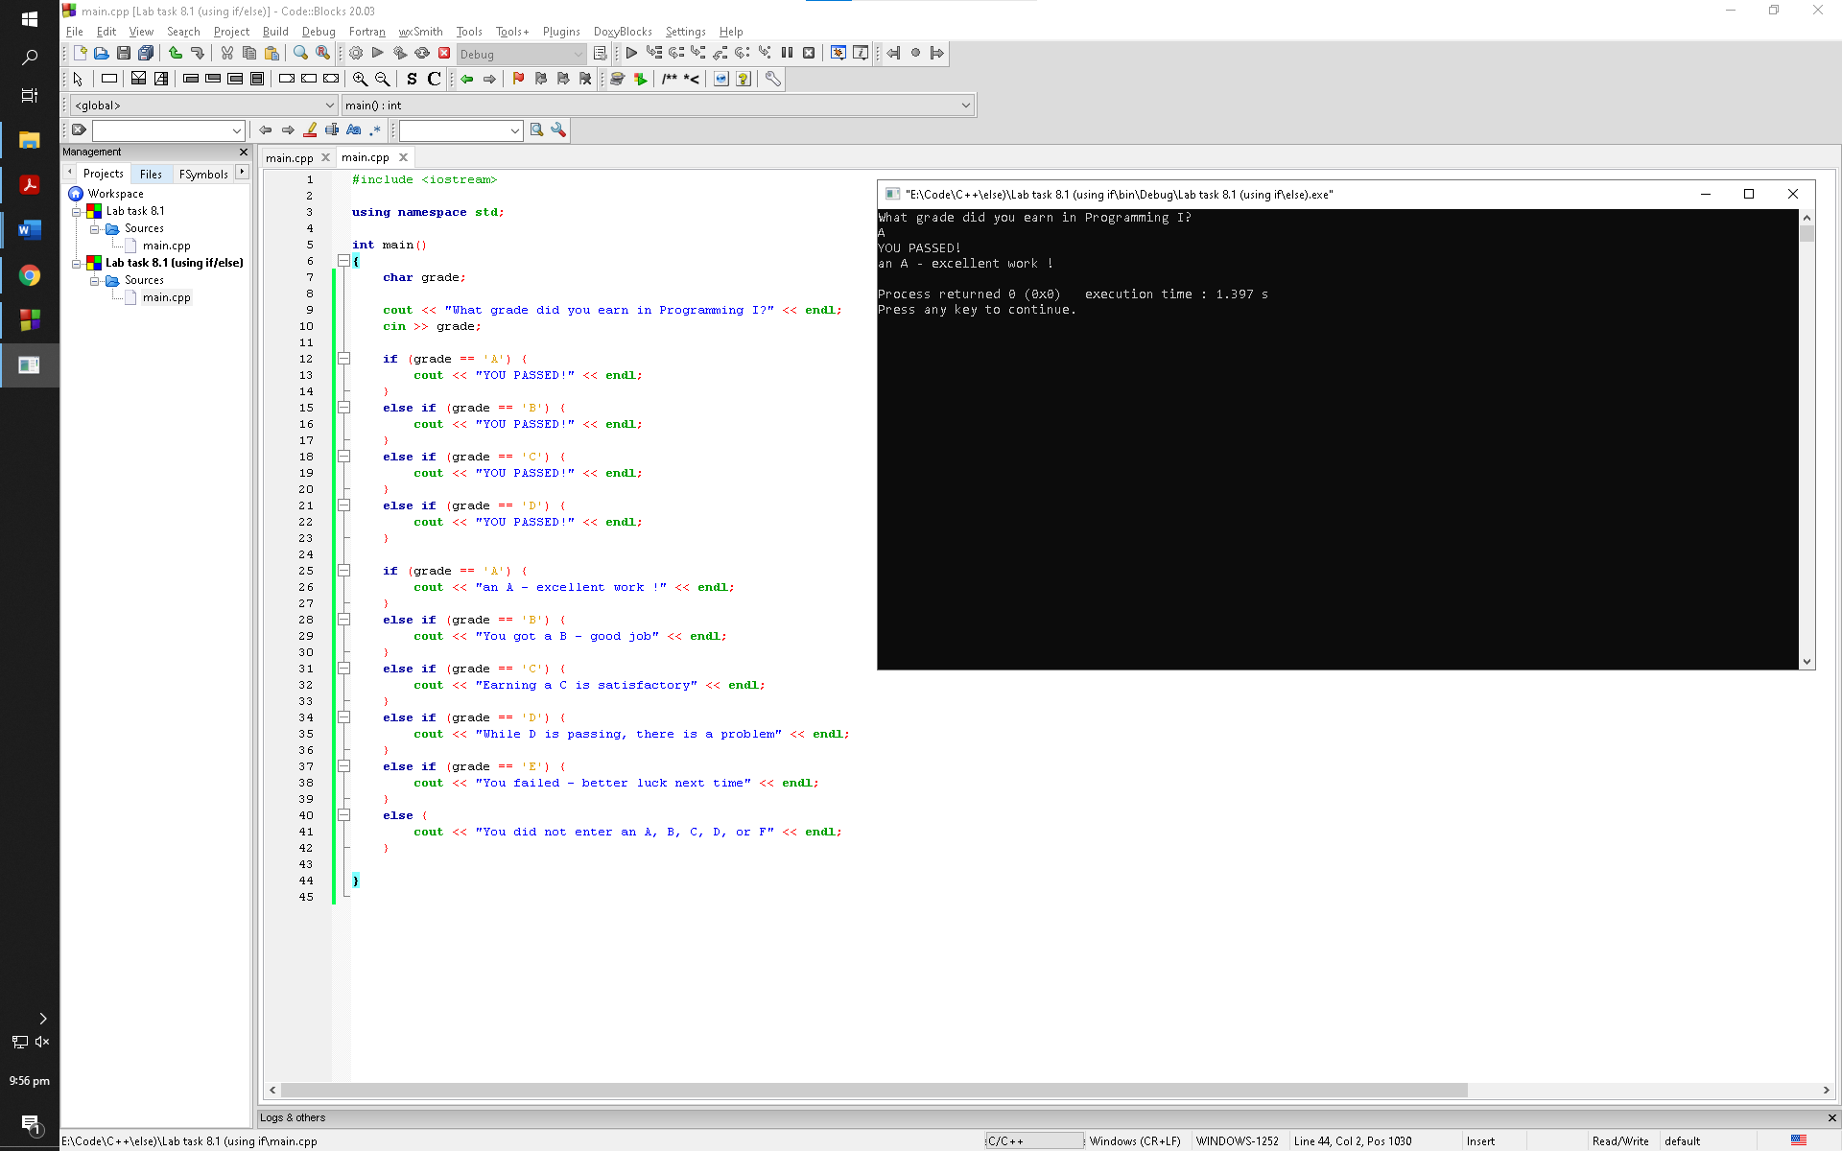

Observation: After taking in input from the user the program goes through the first if statement and checks if its true. If its not true, the program moves forward until the second if statement and checks the next else ifs and prints the corresponding cout statement if true. The program then moves on to the second if statement and the exact same thing. If none of the if and else if statements are true, the program prints out the trailing else statement which corresponded to the default statement in Exercise 2

Lab task 8.2

Sample run 1

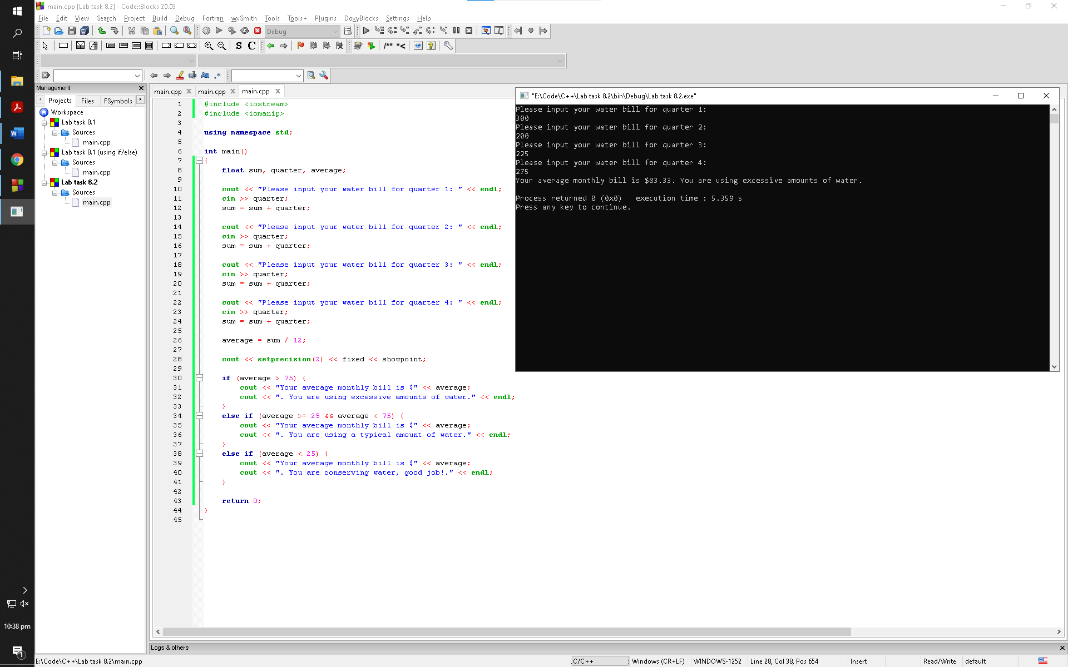

Observation: The program prompts the user to input the amount of water bills of 4 months and then calculates their average of a year. It then checks the if and else if statements with the average and prompts the user with cout statements accordingly

Sample run 2

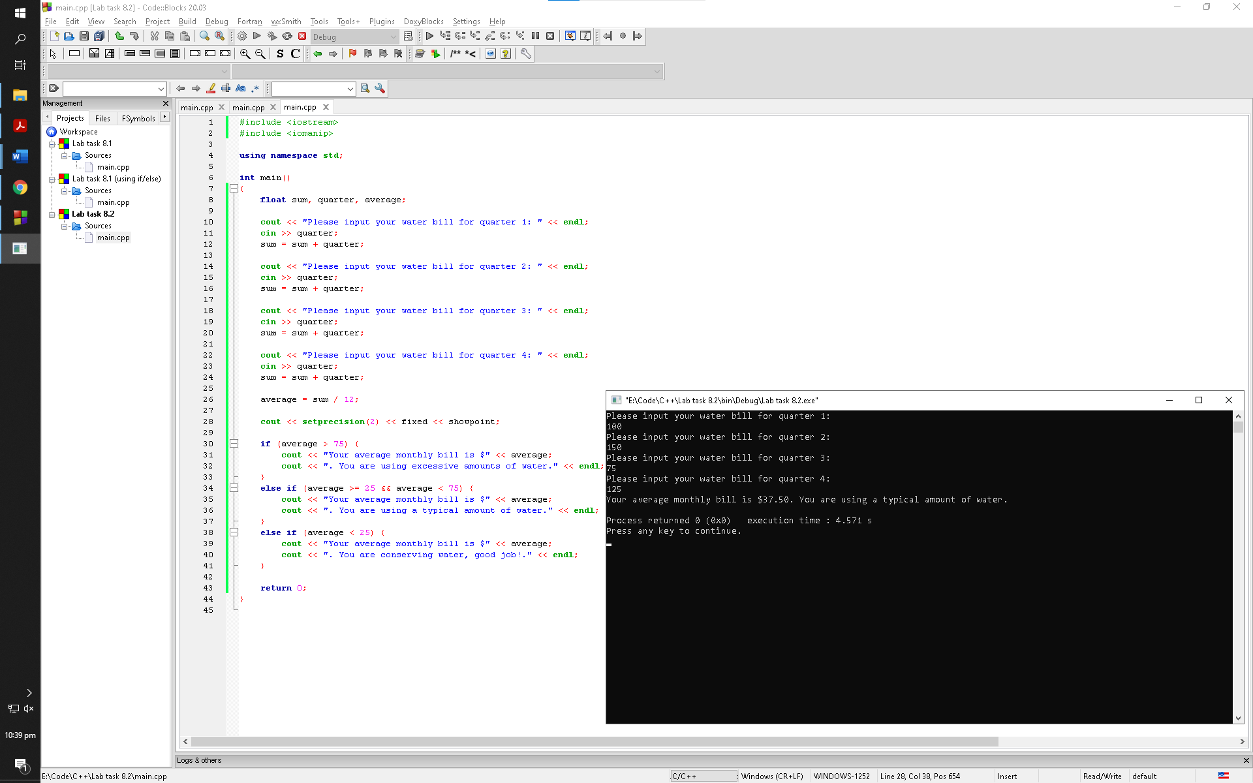

Observation: The program prompts the user to input the amount of water bills of 4 months and then calculates their average of a year. It then checks the if and else if statements with the average and prompts the user with cout statements accordingly

Sample run 3

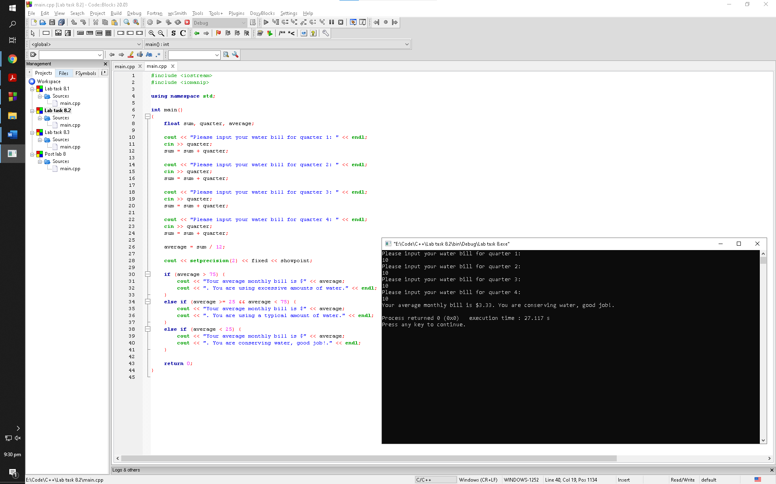

Observation: The program prompts the user to input the amount of water bills of 4 months and then calculates their average of a year. It then checks the if and else if statements with the average and prompts the user with cout statements accordingly

Lab task 8.3

Sample run 1

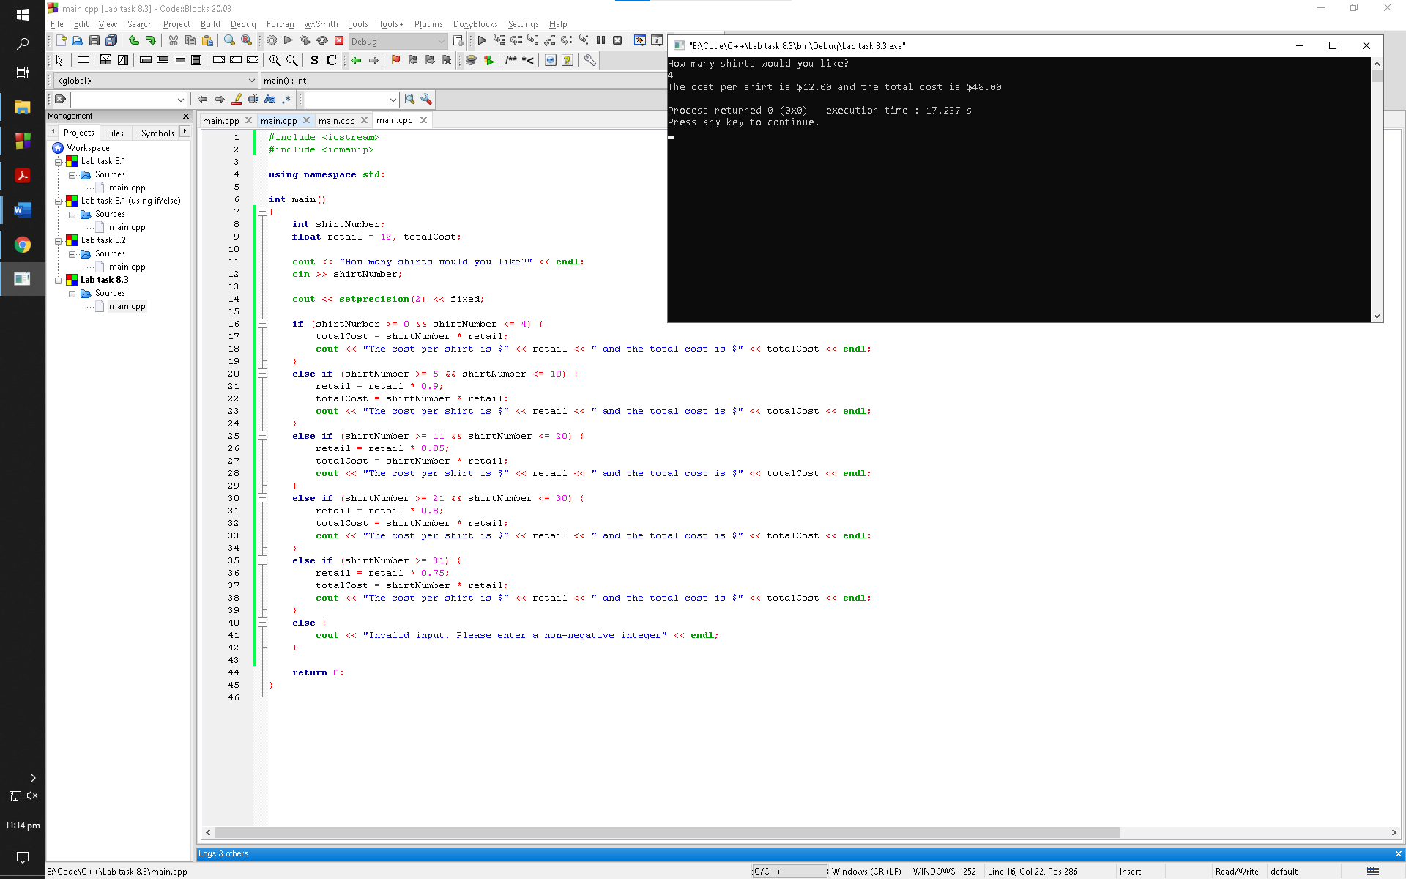

Observation: The program prompts the user to input the number of shirts. It then checks the if and else if statements and prompts the user with discounted prices and the total price of the shirts accordingly

Sample run 2

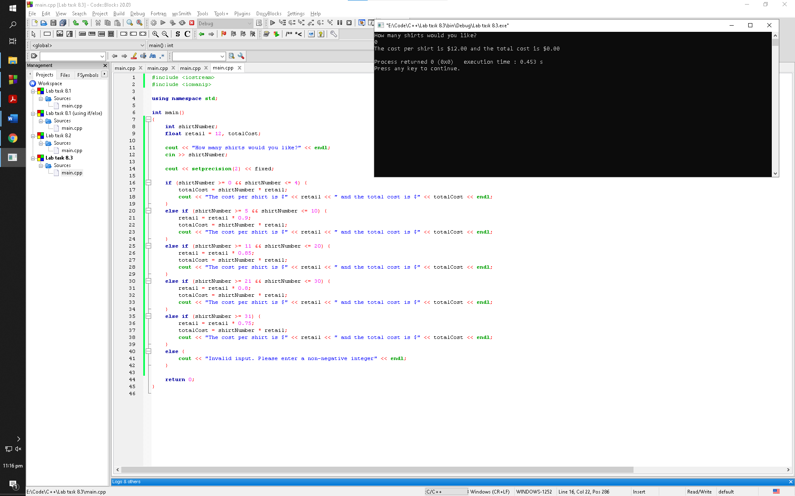

Observation: The program prompts the user to input the number of shirts. It then checks the if and else if statements and prompts the user with discounted prices and the total price of the shirts accordingly

Sample run 3

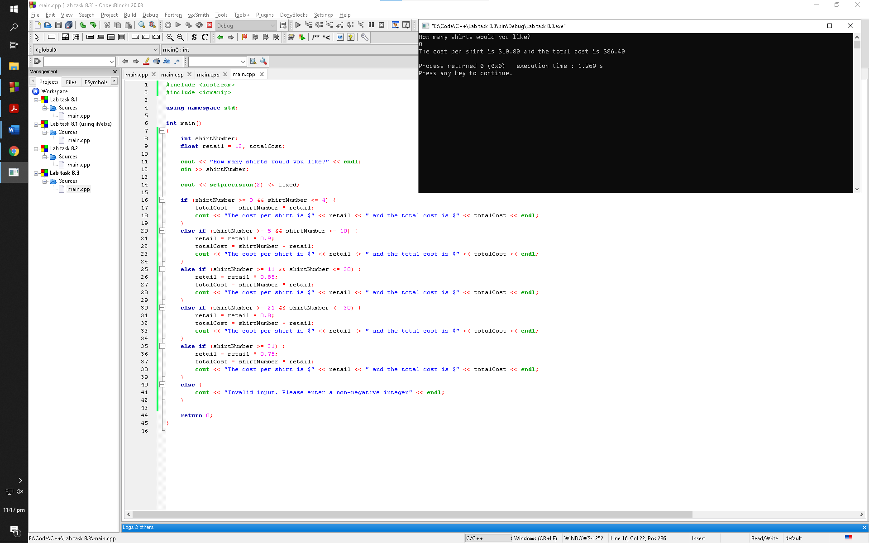

Observation: The program prompts the user to input the number of shirts. It then checks the if and else if statements and prompts the user with discounted prices and the total price of the shirts accordingly

Sample run 4

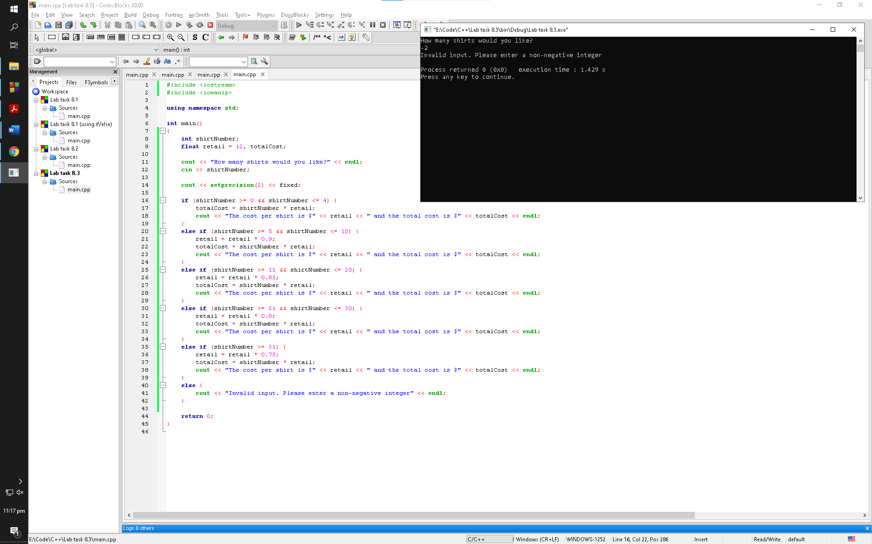

Observation: The program prompts the user to input the number of shirts. It then checks the if and else if statements and prompts the user with discounted prices and the total price of the shirts accordingly

Post lab

Sample run 1

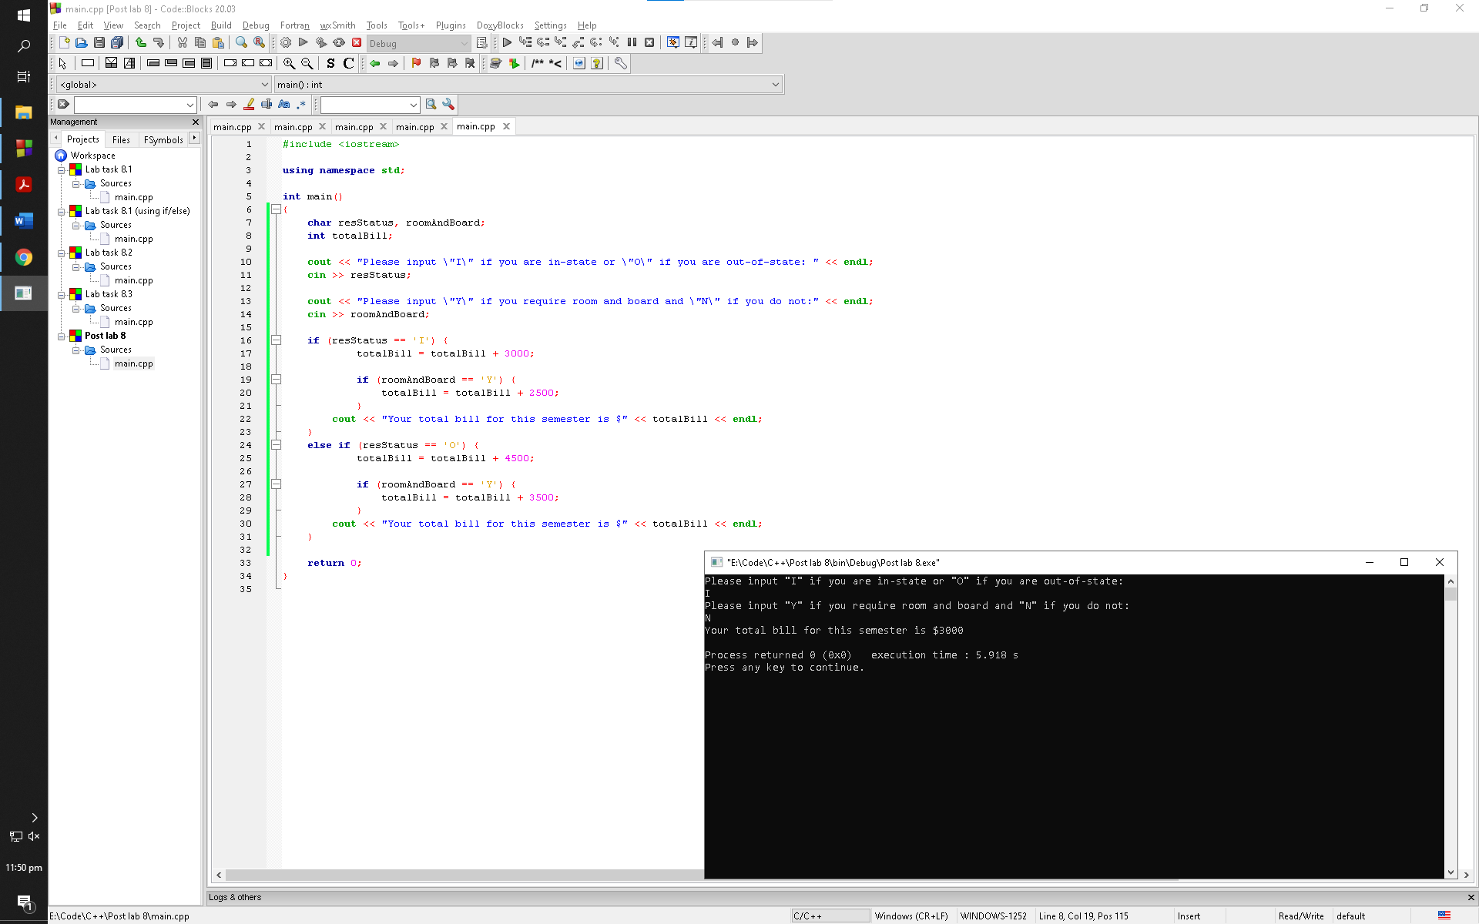

Observation: The program prompts the user to input their residential status and whether or not they want room and board. It then prompts the user with their bill for the semester accordingly

Sample run 2

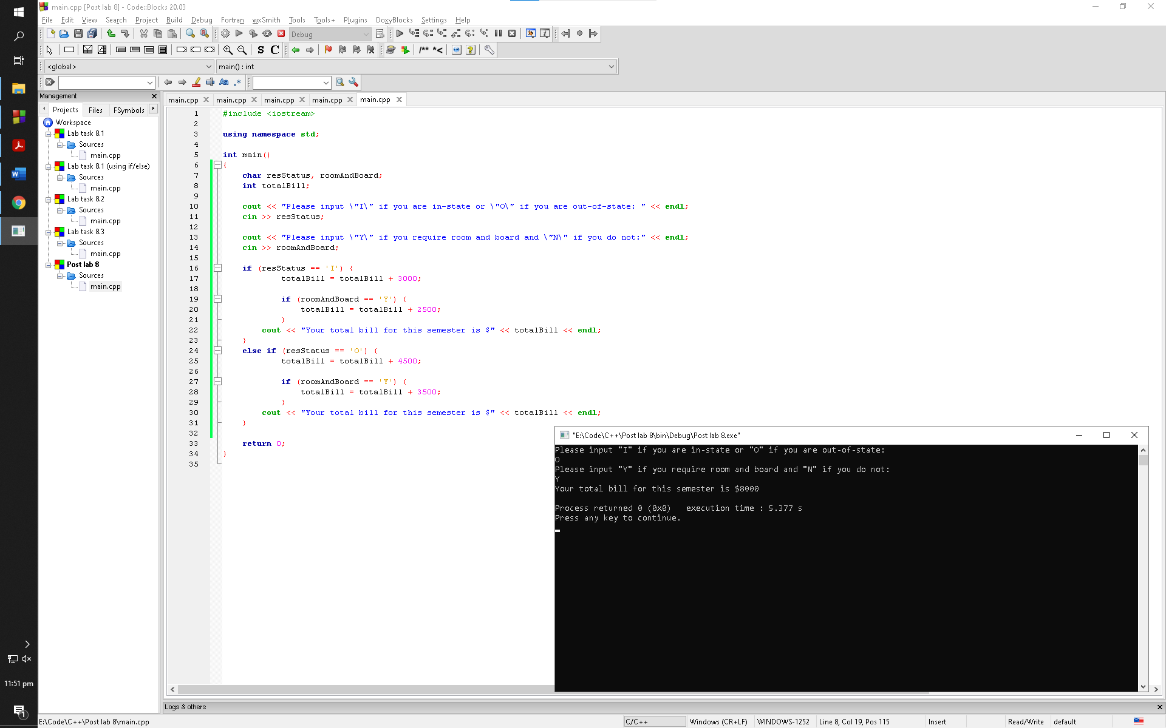

Observation: The program prompts the user to input their residential status and whether or not they want room and board. It then prompts the user with their bill for the semester accordingly